

Microsoft Teams video consultations
A guide for patients
Video appointments are a quick and secure alternative to in-person appointments, allowing you to attend your consultation in a setting that is convenient for you.

You will be able to join your video consultation using a link sent to you in advance. Depending on the service, this link may be sent to you:


By email


By text message


By letter

Why choose video consultations?

- We can see how you are.
- It can save you stress, time and money.


What you will need to attend your video appointment:

Your video appointment will be held using the Microsoft Teams application.

Patients can connect to an appointment on a PC, laptop, tablet, or smartphone device.

To join a Microsoft Teams appointment, you will need one of the following browsers installed on your device:

- Microsoft Edge
- Google Chrome

You should make sure that you have one of the latest browser versions installed on and a good secure internet connection.

How to install Microsoft Teams

If you are joining a Teams video consultation on a smartphone, you should download the Microsoft Teams application before your video consultation meeting takes place.

If you are joining the Teams video consultation on another device such as a laptop, installing the Teams Application is not mandatory, but recommended.

We recommend installing Microsoft Teams on your device for a better user experience.

Downloading Microsoft Teams is free, but you need a Microsoft account.

If you have a Microsoft Account, please follow the steps below:

- For Windows and Mac: Visit the Microsoft Teams website

- For iOS (iPhone/iPad): Go to the App Store, search for “Microsoft Teams”

- For Android: Visit the Google Play Store, search for “Microsoft Teams”

You will need:

- A private, well-lit area where you will not be disturbed.
- A good, reliable internet connection.
- A PC, laptop, tablet or smartphone.
- A web camera, speakers, and a microphone (Most devices have these built in).

Are video calls secure?
Your privacy is protected to current Microsoft industry standards.

How much does it cost?
Your video appointment is free. However, you may be charged for internet usage, data usage by your provider.
How to join your video appointment:

Please read these instructions at least 24 hours before your video appointment. Just like in-person appointments, delays are possible, and we thank you for your understanding.

Setting up

- We will send your appointment time and the information you’ll need to access your appointment via email or letter.

- We may send you an email reminder.

- Make sure you are familiar with the software before your appointment.

- Make a list of questions or issues before the call to help you get the most from your consultation.

Starting the Teams Video Appointment

- To join your appointment from your confirmation email either:
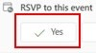
Click yes in the RSVP section to confirm that you are going to join the meeting. This may add the appointment to your calendar from where you can join the meeting directly.

OR

Use the joining details located at the bottom of the page to join the meeting directly.

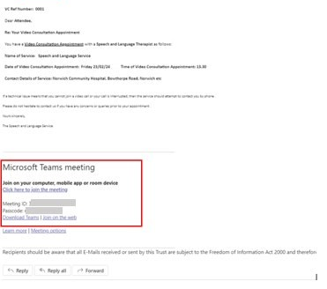

If you have received a paper letter it should include joining instructions for you to follow.

- Your appointment can open in different ways:

If you have the Microsoft Teams Application installed on your device, your appointment opens there – Click here to Join the meeting.

If you don’t have the app, your appointment opens in a Web Browser. – Click here to join the meeting.

If you are joining the meeting on a smartphone device, you will be taken to the app store to download/ get the app.

Once the app has downloaded, you will be given two options for joining your meeting:

- Join as a guest
- Sign in and join

Choose to join as a guest.

If you are joining on a laptop or desktop device, you should be given the option to continue on this browser or install teams and join on the Teams Application.

Join via the web if you have been sent a Meeting ID and Passcode in a letter or email.

If you are joining the meeting on a smartphone, you’ll be taken to the app store to download the app.

Once the app has downloaded, you'll be given two options for joining your meeting:

- Join as a guest
- Sign in and join

Choose to join as a guest.

Joining via the Microsoft Teams app:

- If prompted select join on Teams app.

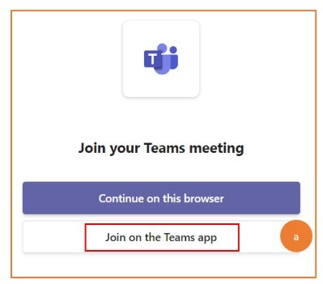

- Select open to allow access to Teams and select the correct account and enter your username and password if prompted.

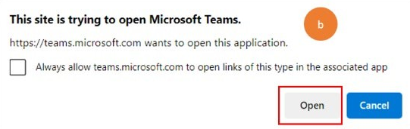

- Click allow to let Microsoft Teams use your microphone and camera.
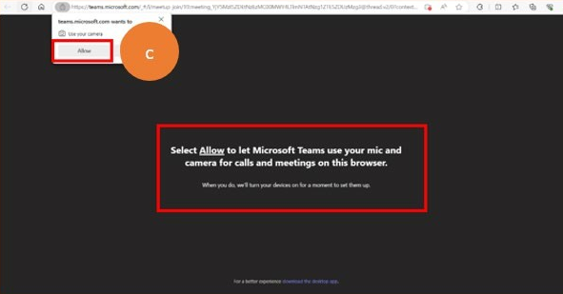

- Type in your first name if prompted.
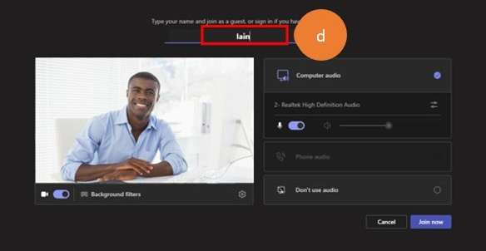

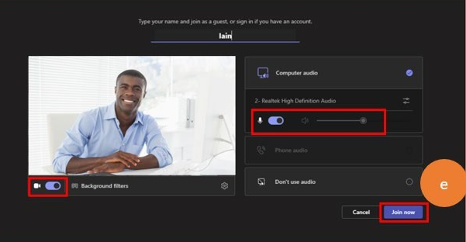
- Check your microphone and camera are switched on and select join now.

Joining via a browser:

This process may vary depending on which device and browser you are using, so you will have to follow the instructions given on your screen.

- If prompted select continue on this browser and follow the same steps above.
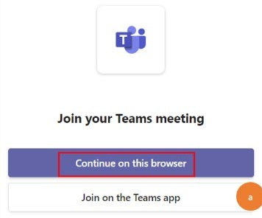

Joining via a Meeting ID and Passcode link in an email or letter:

- Click on the join on the web hyperlink which is included in your appointment joining details.

OR

You will need to manually type in the following hyperlink into your web browser:
https://www.microsoft.com/en-gb/microsoft-teams/join-a-meeting?rtc=1

- This will take you to the page below:

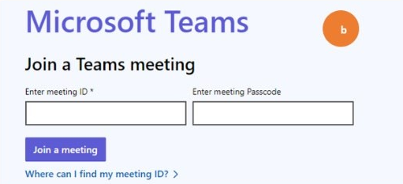

Manually enter your meeting ID and enter meeting passcode as displayed on your letter or email correspondence from the service and select join a meeting.

Waiting in the lobby

You’ll be added to a lobby, and the appointment owner will be notified that you're waiting. When they’re ready, they will admit you into the meeting. If the clinician is running late, they may send you a chat message.

Your clinician will join the meeting. You can look at your doctor or nurse’s face on screen whilst you are talking, there is no need to look directly at your camera.

During the Consultation

During the appointment you can:
- Turn your video on and off.
- Share your screen - available on some browsers.
- Send chat messages - take care when using chat messages and remember that they may be seen by all those on the call, the organisers of the call, including those who have left the call before it finishes.

Important information: Chat messages can be visible to users in the Teams app for up to seven days after the expiration period that the Trust has configured in the retention policy.

Ending the video call

Feel free to ask us any questions before you go and provide us with any feedback about the quality of the call.

We’ll say goodbye.

Once the appointment is complete, the staff member can end the call, or you can select hang up or leave.

Troubleshooting tips

If a technical issue means that you cannot join a video call or your call is interrupted, then your clinician will attempt to contact you by phone.

For appointment-related queries, please call the service number listed on your correspondence.

Guidance for patients

Make sure that you have a safe, quiet, confidential place that is free from interruptions for your consultation.

If another person is present in the room, you should consider making your health and care professional aware, particularly if the other person remains quiet or is not visible to the health and care professional. This helps your health and care professional avoid inadvertently breaking confidentiality.

Your health and care professional will inform you if anyone else is in the room with them and ask if you are comfortable with this, for example, if they have a student doctor working with them.

You may be asked to confirm your details, for example, name and date of birth to ensure you are the right patient or service user.

If you wish to record the session with your own applications or another device, it is good practice for you to advise your health and care provider in advance and out of politeness check they are happy with this.

If you have any concerns when offered a video consultation, please speak to your health and care organisation.

Feedback
If you have any queries about our services, or would like to provide feedback, please contact our Patient Advice and Liaison Service (PALS):
- Telephone: 0800 088 4449
- Email: eec.pals@nhs.net.
- Opening hours: Monday to Friday, 9am–5pm

Friends and Family Test
You can also tell us how likely you are to recommend our service to friends and family if they needed similar care or treatment. Your feedback helps our staff understand what they are doing well and where improvements can be made.
Ask a member of staff for a Friends and Family Test form, or visit: eastofenglandcommunityhealthandcare.nhs.uk/patient-experience/patient-advice-and-liaison-service-pals/

Produced by: East of England Community Health & Care NHS Trust
Date of publication: May 2026
Leaflet review date: May 2027 Version: 1

