

Caroline House: Complex Neurological Rehabilitation Service
A guide for patients and carers
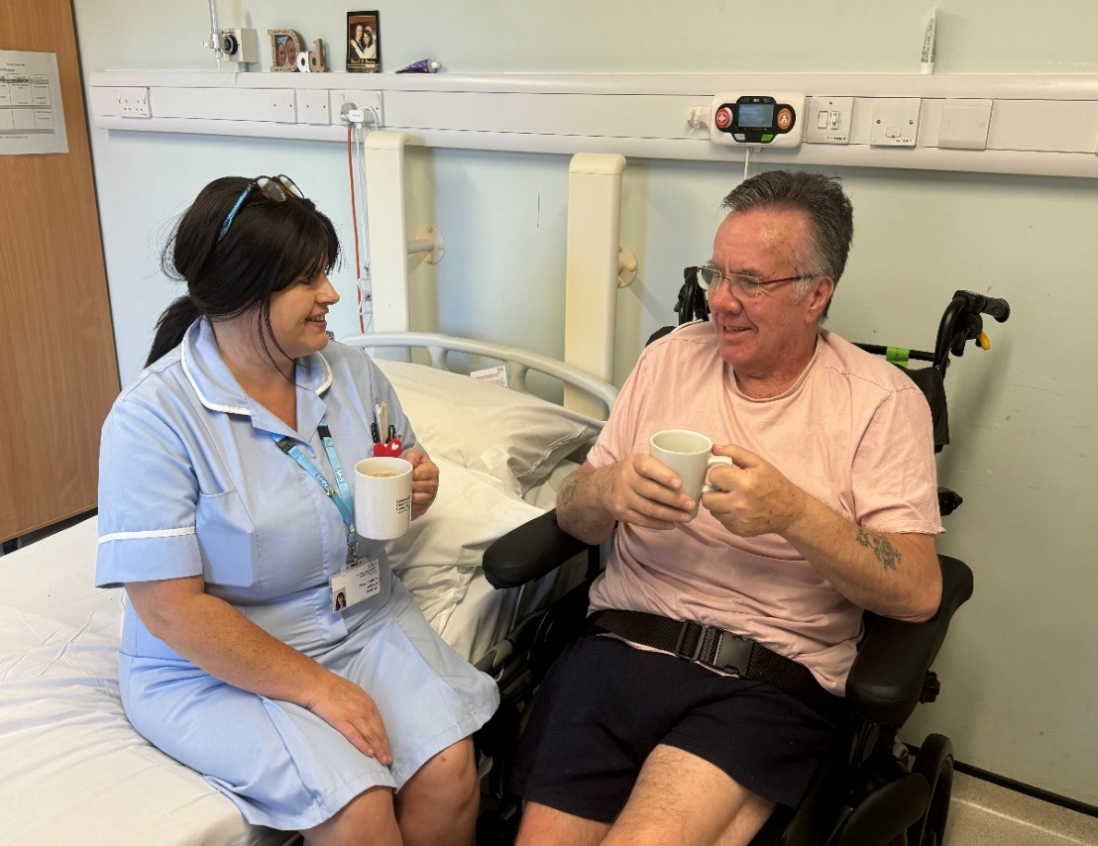

Welcome to The Colman Centre
for Specialist Rehabilitation Services

The Colman Centre for Specialist Rehabilitation Services provides specialist services for patients with complex disabilities that are a result of conditions such as acquired brain injury, spinal injuries, and limb loss.

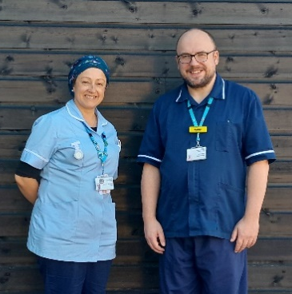
As part of East of England Community Health and Care NHS Trust, our professional staff offer care to patients from the Eastern region. The Colman Hospital site is on Unthank Road in Norwich.

In this booklet we have tried to include all the information you will need to help you, your family or carers. If you have any further questions, please do not hesitate to talk to a member of the team.



The unit came with high recommendations and, as far as we are concerned, it lived up to and surpassed any expectations we had; the atmosphere and general respect shown to our son and us as worried relatives was faultless...

There are a range of additional advice leaflets available within the unit. Please just ask for further information.

You might also like to visit our Trust’s website at: www. eastofenglandcommunityhealthandcare.nhs.uk

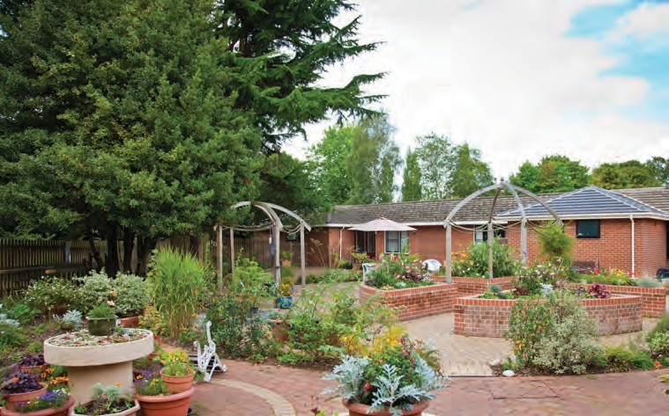

Caroline House: General Information

Set on good local bus routes and not too far from the city centre, the unit is built on one level and has an open style, surrounded by gardens and outside spaces.

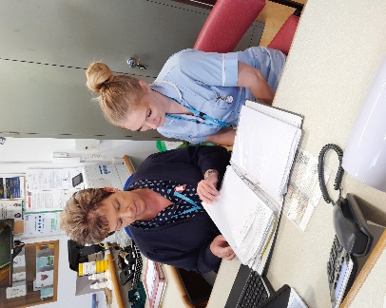
During your stay at Caroline House, you will have a room with en-suite shower facilities. To help manage the safety of all of our patients there may be times when we require people to move rooms.

The unit has a dining room and lounge. This is also used for group work and treatment sessions for patients, so we ask that people understand these sessions will take priority.

Caroline House: General Information

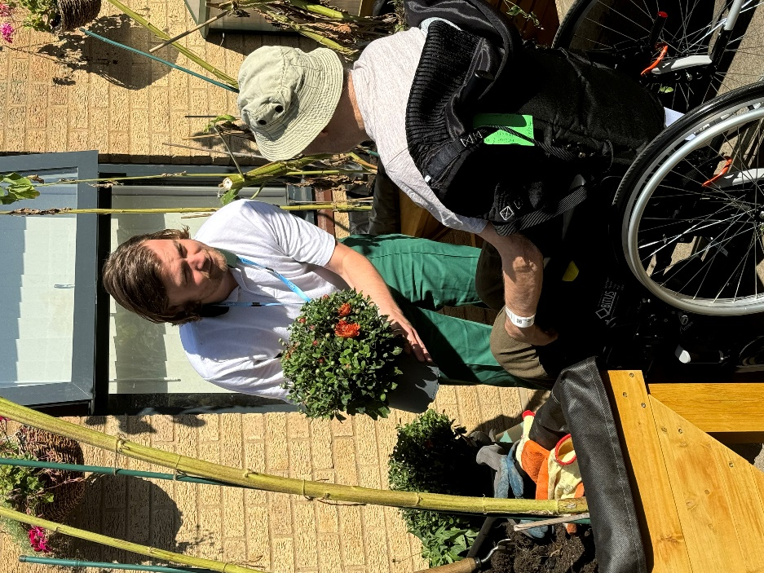

Individual rooms have been set up to create the best environment to facilitate rehabilitation for patients.

We aim to maintain the standard of these facilities. This is to enable staff to provide care and ensure high standards of cleanliness.

We politely ask that nothing is stuck on the paint work in patient areas and that medical equipment is kept clear of obstructions. Please discuss with your team alternative options. Lockers and wardrobes are available for personal items.

What are the arrangements for visitors?

 Visitors
Family, children and friends are welcome to visit.
We ask that you, your family and visitors consider the privacy of other patients and:
- Show courtesy and respect to other patients, family members and all staff.
- Work with staff to get the most from this period of rehabilitation.
- Communicate appropriately with the relevant member of the team. Don’t hesitate to ask questions.
- Please log your vehicle registration at reception to park on site and use the appropriate bays.
- Further information on visiting can be found in the welcome pack in the patient’s room.

 Visiting times
Visiting is held daily between 10am - 8pm.
If it is difficult for your visitors to attend during these times, please discuss this with your team and they will do their best to help arrange a suitable option.

At times staff may be required to deliver care or treatment based on individual needs. This is important for their recovery and for their privacy and dignity.


 Pets
Pets may be brought in at the discretion of the nurse in charge. We have an information leaflet on bringing pets into the unit and your visitors are responsible for cleaning up any mess your pet makes.

Security
For security purposes, the unit will be locked at the discretion of the nurse in charge who manages this based on the safety needs of the unit. If the unit is locked there is a doorbell to request access.

What are the arrangements for mealtimes?

 Protected mealtimes
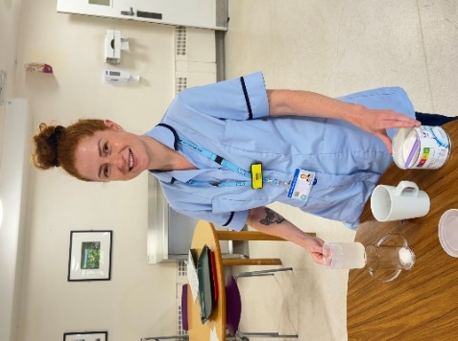
Mealtimes are an important part of your rehabilitation and recovery, and you may be encouraged to use the dining room. We run a protected mealtime system, which we ask visitors not to disturb, to help provide the ideal environment for you to eat your meals with minimal distractions.

- Breakfast – 7:30am
- Lunch – 12:30pm
- Supper – 5:15pm

A choice of meals and drinks are provided throughout the day.
Please discuss any special dietary needs that you may have with the nursing staff or housekeeper. Our aim is to ensure all dietary needs are catered for. Nutritional advice is also available from the nursing team or arrangements can be made for you to talk to the dietician.

Advice around foodstuffs
The unit cannot take responsibility for the safe handling of food we have not provided and, due to food hygiene standards, we advise against family / friends bringing food in for you.

If, however, you feel this is the only option to ensure your nutritional needs are met then please see our information leaflet about foods which may be at ‘high risk’ of contamination.

Essential foods which are not ‘high risk’ can be stored in the ward fridge for a short time providing it is in an appropriate container, with a name and date on. Please discuss this with the nursing and housekeeping team who can provide labels, if required. Items left in the fridge unlabelled or with a shelf life of less than 24 hours will be removed and disposed of.

What facilities are available at Caroline House?

Visitor facilities
There is a snack vending machine in reception. There are also local shops and cafés close to the unit. A member of staff will be happy to advise your visitors how to find these.

 Laundry
We ask that you arrange for your family/carer to do your laundry. If you are unable to launder your own clothes, please discuss this with the nursing/housekeeper team. Clothing should be labelled. We cannot take responsibility for lost or damaged items.


 Chaplaincy
The hospital Chaplain will visit you at your request regardless of your faith. Alternatively, arrangements can be made for you to be seen by someone from your own faith.

 Newspapers and magazines
We do not have a delivery service for newspapers; however, some visitors have arranged this with the local newsagent by paying in advance for a paper to be delivered. They will need to ensure your name is clearly marked on the front of the paper by the newsagent to ensure it can be passed on to you.

Other services not provided by the NHS
Please discuss with the ward staff who will explain how to access these services.

What should I bring with me?

Please bring:
- Comfortable clothes and sensible shoes which are suitable when attending therapy sessions, and night wear. Storage is limited within your room so only bring enough for a few days at a time.
- Personal toiletries
- An outdoor coat may be useful to go out on visits as part of your rehabilitation.
- You may also find it helpful to bring a pen, paper and diary with you.


Personal property and valuables
We regret that the unit cannot accept liability for money or valuables and you are therefore advised to leave these at home for safe keeping.

If leaving your valuables at home is not an option, the nurse in charge can place this in the hospital safe and give you a receipt. On discharge you will need to ask the nurse in charge to arrange for the items to be returned.

Electricals
For safety reasons please ensure any electrical items brought onto site are in a safe working order. Staff will need to perform a visual inspection.

Mobile phones
You are more than welcome to keep your mobile phone with you during your stay in the unit. Free Wi-Fi is available on the ward.
You may be asked:
- Not to take your mobile phone into your therapy sessions.
- To use your mobile phone in the privacy of your room.

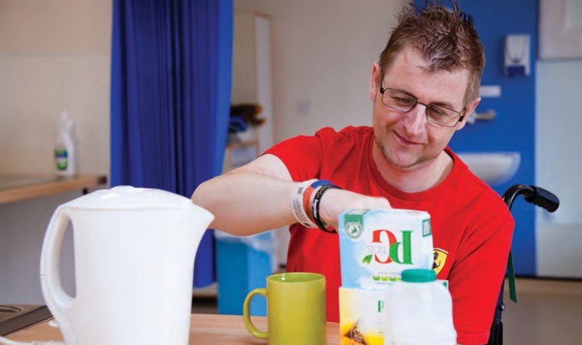

What can I expect while I’m at Caroline House?

Setting your own goals
During your stay at Caroline House, the team will carry out assessments to help identify the rehabilitation goals you might wish to/need to achieve during your stay.Staff will work with you to create goals and a program of care which is tailored to your specific needs.

Reviewing your progress
Usually within three to six weeks – depending on your estimated length of stay – you and your family/carer will be invited to a Patient Review Meeting. This is an opportunity for you to meet with the team as a whole and discuss future goals, progress, and your discharge plan. Depending on your length of stay you may have more than one meeting.

The team will also have fortnightly meetings, called Case Conference Meetings, to discuss your goals, therapy plan and progress. You will be invited to discuss these meetings with your Keyworker.

Your therapy timetable
Within the first two weeks of your stay with us you will have a weekly timetable of therapy sessions created to achieve your rehab goals. Please note some sessions are planned on the day so may not appear on your timetable.

What can I expect while I’m at Caroline House?

Medicines
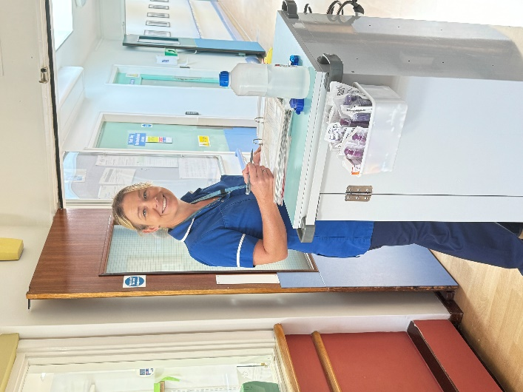
Your prescribed medications are administered by the registered nursing staff.

All medicines must be locked away for safety reasons so please ensure all are given to a registered nurse – even if these are over-the-counter remedies as these may have an effect on prescribed medicines.

As part of your rehabilitation goals, we may support you to take your own medicines.

Staff will discuss this with you and carry out an assessment to enable you to manage this safely.

We work closely with our pharmacy team to provide your medication in a way which is suitable and safe for you during your stay in the unit, and for when you are discharged.

If you have any concerns about your medications, please discuss these with the nursing / medical staff.

It’s difficult for me to find the right words to express my gratitude to everyone at Caroline House. As you will know, I was a poor old thing when I first arrived here and thanks to the care and kindness shown to me, I’m finally ready for the outside world....

Who will provide my care?

Your care will be provided by a team of health and social care professionals who have the experience, skills and knowledge to offer you a rehabilitation service. You may need support from some of these professionals, or all of them.
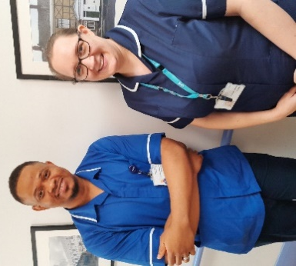
The team includes:
- Consultant led medical team
- Nursing team
- Physiotherapists
- Occupational Therapists
- Rehab and Nursing Assistants
- Speech and Language Therapists
- Clinical Psychologists
- Dietician
- Social Workers
- Discharge co-ordinator
- Keyworker - a leaflet explaining the role of the Keyworker will be given to you. They will work with you and your family/carer to identify therapy goals.

Doctors
Doctors at Caroline House help to identify medical issues which might slow down a patient’s recovery following a neurological injury. They will put in place medical therapies (medicines, etc) to help while recovery is taking place, and they work with you and your family to help you understand your injury, and the long-term implications it might hold for your life.

Rehabilitation Nurses
Rehabilitation Nurses are a pivotal member of the team, working as the patient’s advocate. Working closely alongside colleagues, the nursing team ensures that patient’s total care needs are met 24-hours-a-day, seven-days-a-week to optimise you to be able to take part in their therapy sessions.

Physiotherapists
Physiotherapists work with patients to help improve their movement, posture and function, as well as helping them avoid any complications which can be caused by immobility. Working with you they will create an individual programme of therapy set around your own goals, to help you achieve your full potential.

Occupational Therapists
Occupational Therapists help people achieve as much independence as possible in their everyday activities. After assessing each person’s physical, cognitive, social and environmental issues, with involvement from family, carers and friends, Occupational Therapists can offer rehabilitative interventions or treatments.


Speech and Language Therapists
Speech and Language Therapists work with patients with communication difficulties offering therapy and support to you and your family and carers, helping people to communicate more successfully. They also help patients with swallowing difficulties, advising on the safest consistency of food and drink and providing therapy when appropriate. They will also have a key role working with patients with a tracheostomy.

Clinical Psychologists
Clinical Psychologists are here to assess and help patients overcome emotional or psychological difficulties following an acquired brain injury, using recognised therapies. They also help a patient to manage issues such as memory loss, changes in their behaviour due to their injury or condition and offer additional psychological support to families and carers.

Social Workers
They advise and support patients, and their families and carers, on how to access appropriate services and social care as they prepare to leave the unit. With a patient’s agreement, they can liaise with and refer to other organisations for things including benefits advice, assistance with application forms, or help with managing finances. They can assist in setting up support plans for patients who are eligible for local authority funded personal budgets and will advise any patients who are not eligible.

Discharge Coordinator
Our discharge coordinator works with patients and the ward team to facilitate a safe and organised discharge. They are likely to meet with you / your family / carer early on in your stay to discuss this.

What are the arrangements for my discharge and follow-up treatment?

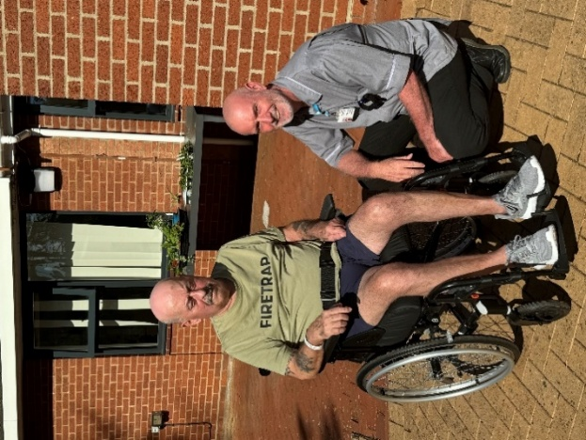
Planning around your safe discharge from the unit will start within the first week of your admission and this planning will continue during your rehabilitation.
It is not always possible for every patient to fully achieve their therapy goals; however, rehabilitation can continue after discharge. The team will discuss with you if you need to be referred to an outpatient therapy team after you leave, based on your needs and where you will move on to.

Medication
When you are discharged you will be given a minimum of two weeks’ supply of your medication. After this, you will need to get a prescription from your own GP.

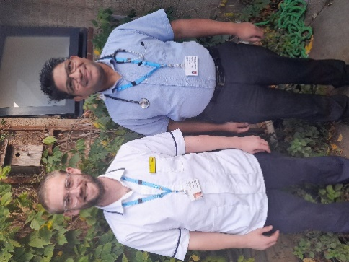
Community services
Your GP will be told that you have been discharged and will be given details about what has happened while you have been in hospital.

Arrangements may be made for a community nurse to visit you at home, or you may be asked to see your practice nurse at your GP surgery or health centre.

Your experience of our care
As part of our aim to continually improve the quality of our services we need to know what you think about the care we have provided. We want to hear any comments you may have so that we can keep getting better together.
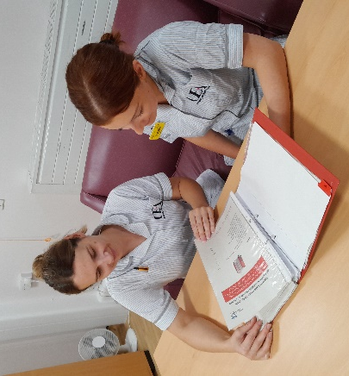
If you do have concerns about any aspect of your own, or your relative’s care during your time at the unit we would urge you to speak to a member of staff as soon as possible to help us put things right straight away. If you feel that your concern has not been resolved, please contact the Ward Manager (Monday to Friday).

We also love to receive your positive feedback and compliments as these let us know we are doing our job correctly – letters and cards can be handed in at the unit.

Comments, Compliments and Complaints
A leaflet on how to formally lodge your Comments, Compliments and Complaints is available from a member of staff or you can log onto our website at: www.eastofenglandcommunityhealthandcare.nhs.uk

Charitable Donations
If you would like to make a charitable donation to the centre, please ask a member of staff for the ‘Supporting your local community health service’ leaflet which will give you all the information you need to make your donation.

Further information or advice
The following agencies may also be of interest to you:

Citizens Advice Bureau (CAB)
Provides confidential and free advice and information.
Web: www.adviceguide.org.uk

Stroke Association
Provides support and advice for those who have had a stroke, their families and carers.
Tel: 0303 3033 100
Web: www.stroke.org.uk

Headway
Provides information, support and services to people with a brain injury, their families and carers.
Freephone: 0808 800 2244
Web: www.headway.org.uk

Spinal Injuries Association
Provides advice and support for those who have had a spinal injury, their families and carers.
Freephone: 0800 980 0501
Web: www.spinal.co.uk
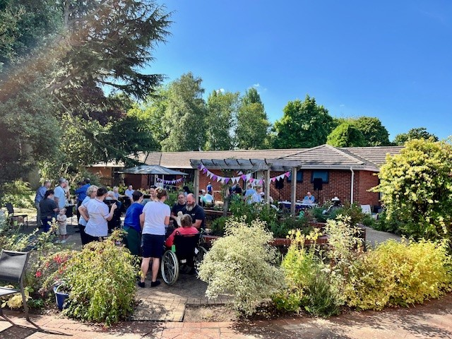


If you would like this publication in large print, Braille, alternative format or in a different language, please contact us on 0800 088 4449 and we will do our best to help.

Feedback
You can receive help with queries about NCH&C services, or provide feedback about them, by contacting Patient Advice and Liaison Service:
Telephone: 0800 088 4449
Email: eec.pals@nhs.net
(Monday to Friday 9am to 5pm)

You can also tell us how likely you are to recommend our service to friends and family if they needed similar care of treatment. Hearing your views helps our staff understand what they are doing well, and where improvements can be made.

Ask a member of staff for a Friends and Family form or scan this code:

Produced by East of England Community Health and Care NHS Trust
May 2026
Leaflet review date
May 2027
Version 1

