CADRE-Cambridge Privacy Notice
(Easy Read Version)
CADRE-Cambridge (“Children and Adolescents Data Resource”) is a database. A database is a safe place where information is kept. This information is collected from health, education and social care services. Researchers use this information to help make mental health services better for young people.
Research means reviewing information to learn more about human beings and our health care services so we can make things better.
This note covers CADRE-Cambridge and has been prepared on behalf of all responsible organisations that participate. When we use words such as “we” or “our”, we mean the participating organisations as a whole.
This document has last been updated in September 2026.
Who are we?
CADRE-Cambridge is a database that receives information from the following organisations:
 | Cambridgeshire and Peterborough NHS Foundation Trust offers lots of NHS services to people who live in Cambridgeshire and Peterborough. Please see their separate privacy notice for contact details.
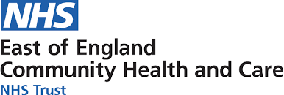 | East of England Community Health and Care NHS Trust offers lots of community services to people who live in Cambridgeshire, Peterborough, Bedfordshire, Luton, Norfolk and Waveney and Suffolk. Please see their separate privacy notice for contact details.
 | Cambridgeshire County Council governs the area of Cambridgeshire and offers public services to people who live there. Please see their separate privacy notice for contact details.
These organisations are considered the responsible entities in the CADRE-Cambridge project.
What is this document about?
 | This document is about a database called CADRE-Cambridge.  We wrote this document to give you information about CADRE-Cambridge so that you understand:  - What CADRE-Cambridge is;  - How it works;  - What rights you have; and  - What you can do if you have any questions or concerns about CADRE-Cambridge
What is CADRE-Cambridge?
   | CADRE-Cambridge is a database with information about children and young people. This information is used to help with health research.
 | Sometimes, the information in our Cambridge database can be linked with information in other databases. We call this part of our project the federation. It helps researchers to study more people. Your information stays safe and does not leave the database where it is stored.  Federation means safe sharing between databases without moving your information. This can only happen between safe systems that are part of the federation. All members must follow the same safety rules to keep your information safe.
What information do we use?
   | We get information from health, education and social care services in Cambridgeshire and Peterborough. This means places like your doctor’s office, school, hospital, or Accident and Emergency (A&E).
 | Information about children and young adults in Cambridgeshire and Peterborough includes:  - Background information (like where you’re from);  - Any illnesses or conditions you might have;  - Any help you have gotten from care services to look after your health (like from doctors or nurses);  - Information about keeping you safe (like whether someone is bullying you));  - Any treatment or medicine you have been given;  - Educational data (like your school attendance);  - Information about the clinicians who treated you; and  - Notes about your care, like plans, assessments and check-ups from doctors or nurses.
Information that does not allow us to identify you
   | Any details that show who you are (like your name) are taken out of the information before it goes into our database. We use a computer software called CRATE to do this. A computer software is like a set of instructions that tells the computer what to do. CRATE instructs computers to remove all details that could show who you are. This way, the researchers viewing the data will not be able to identify you from the information in our database. That means they won’t know who you are.  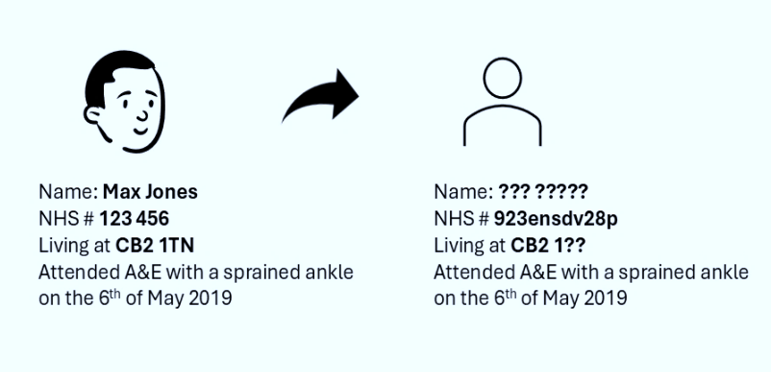  Sometimes, we will need to link the data in our database back to you. For example, this is the case where you let us know that you want us to delete your data. Some of our selected employees will work closely with our data providers. These selected few will be able to link the data in our database back to you so that they can implement your request.
Why and how do we use your information?
We made CADRE-Cambridge to make it easier for researchers to do research about children’s and young adults’ health. Your information is only used for this reason.

Because CADRE-Cambridge combines information about children’s and young adults’ health from different services, it helps researchers to spot patterns and come up with ideas that they might not otherwise have been able to.

Researchers can learn more by using information from CADRE-Cambridge and from other parts of the UK. This helps them study a bigger group of people. That means their research can help more people.

Finally, researchers can also use CADRE-Cambridge to ask you if you want to join their research studies. They can only contact you where you have agreed to them seeing your contact details. If you have not agreed, they cannot see who you are. Your name and details are kept private and safe.

 | CADRE-Cambridge allows for this research to happen by sharing and linking information from different places in Cambridgeshire and Peterborough in one safe database.
   | If a researcher wants to use the information in the database, they must ask for permission from a group called a committee.  The committee will decide whether the researcher has a good reason to use the database and whether the researcher will keep the information safe.  The committee will only let the researcher use the database if they can show they will keep the data safe and that their project will help lots of people in society.
 | If the committee gives the researcher permission, the researcher will be taught how to use CADRE-Cambridge safely. This helps protect your information.  They will only be given access to the information that is necessary for their research. This means that they will not be given any more information than what they need.
How do we follow the law?
   | Under data protection law, we need a reason to use your personal data. We do not ask for consent because the law lets us use other reasons instead. Consent means permission.  The reason we rely on under data protection law is:  - Public interest – This means we use your personal data to do something that helps the public and society.  - Consent – We only ask for your consent if we want to contact you about taking part in a research study.
 | Some of the information we use is sensitive. It needs to be handled with more care. Because of this, we need another reason to use this kind of information.  The reasons we rely on to use sensitive information are:  - Explicit consent – We only ask for your consent if we want to contact you about taking part in a research study.  - Public health – This means we use your information to help keep everyone healthy and make things better for the public.  - Scientific research – This means we use your information to do research that helps people and improves health in the future.  The Health Research Authority has agreed that we can start doing what we have described above about health and social care data. They got advice from a group called the Confidentiality Advisory Group who reviewed this project.  This means we are following the rules about keeping your information confidential.  Confidential means private and not shared with others.

How do we keep your information safe?
   | We keep your information in a database with strong security to keep it safe and secure.  The data is locked away safely, both on computers and in real life. When anyone uses the database, we keep a record and often check what they do. Only a few people are allowed to use the database. They sign an agreement that means they must keep everything they see when accessing the database confidential.  Researchers can only download the information they need, and anything that could identify you is removed. This means they cannot tell who you are from the information they get.
How long do we keep your information for?
 | We only keep your information for five years. It might be kept longer only after a careful review. If you don’t want your information to be in the database, you can always let the CADRE team know.
 | When your personal data is no longer needed, we make sure that it is deleted securely.

Do I have a say in what happens to my personal data?
 |  |  | Yes you do. You have rights about how we use your data. These rights help protect your information.  One of these is the right to know what we do with it. That’s what this document is for.
 |      |  | You can also:  - Ask us to see the information we have about you;  - Ask us to change or complete the information we have about you, if you think it is incorrect or incomplete;  - Ask us to delete the information we have about you;  - Ask us to restrict the way we use information about you; and  - Object to the way we use information about you.  You also have the right to opt-out. This means we won’t use your personal data for this database. To do this you can submit a National Data Opt-Out. NHS England will then make sure that your personal data is not shared outside of your healthcare organisation with databases like CADRE. You can also ask to specifically opt-out of CADRE. In that case, the CADRE team will remove your personal data from the CADRE database.
 |  | If you want to make a request, you can contact us using our contact details below. You do not need to pay to do this.
 |  | If you make a request, we have one month to get back to you.

How can you contact us?
 | CADRE-Cambridge Secure Data Environment
 | The CADRE Research Database Manager, Windsor Research Unit, Fulbourn Hospital, Cambridge Road, Fulbourn, Cambridge CB21 5EF
 | - cadre@cpft.nhs.uk  For more information, you can visit our website: https://cadre.org.uk/

How to ask questions or make complaints?
   | If you are concerned about how we are using your information, you can send us a question or complaint using our contact details above.
 | You can also contact the Information Commissioner’s Office, or “ICO” for short. Their role is to make sure we follow the rules and will tell us if we do things wrong. You can email or write to them using the below contact details:  Address:  - Information Commissioner’s Office  Wycliffe House, Water Lane, Wilmslow  Cheshire, SK9 5AF  Phone number:  - 0303 123 1113  Website:  - https://www.ico.org.uk

