

Pine Cottage:
Specialist Amputee
Rehabilitation Service
A guide for inpatients and carers

Contents

Welcome to The Colman Centre for Specialist Rehabilitation Services | 3
General information | 4
What are the arrangements for visitors? | 5
What facilities are at Pine Cottage? | 6
What should I bring with me? | 7
What can I expect while I’m at Pine Cottage? | 8
Who will provide my care? | 9
Why do I need to have an amputation? | 11
How will I feel after my operation? | 12
When will my clips or stitches be taken out? | 14
What happens if I am going to have an artificial limb? | 15
Further Rehabilitation | 16
Your experience of our care | 17
Further information or advice | 18
Contact Information | 19

Welcome to The Colman Centre for Specialist Rehabilitation Services
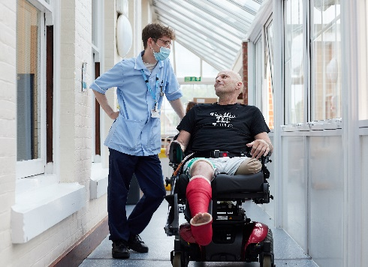
The Colman Centre for Specialist Rehabilitation Services provides specialist services for patients with complex disabilities that are a result of conditions, such as acquired brain injury, spinal injuries, and limb loss.

As part of Norfolk Community Health and Care NHS Trust, our professional staff offer care to patients from in and around Norfolk within two inpatient units and outpatient services based within the Colman Hospital site, on Unthank Road, in Norwich.

In this booklet, covering the services we offer at Pine Cottage, we have tried to include all the information you will need to help you, your family, or carers. If you have any further questions, please do not hesitate to talk to a member of the team.
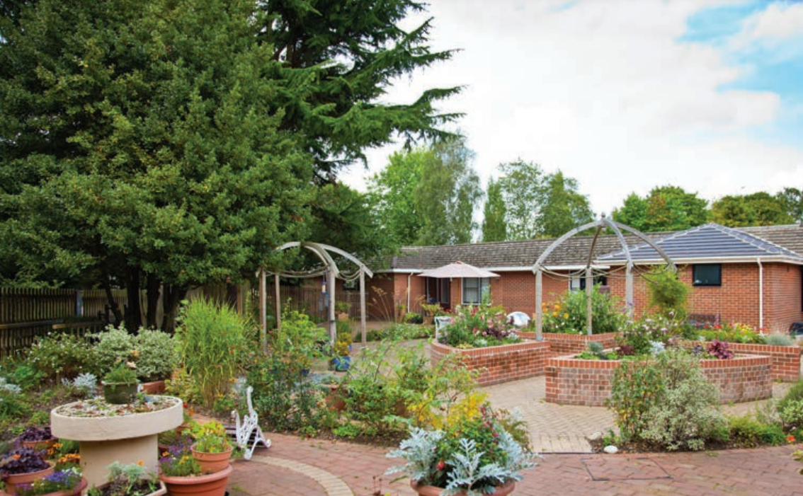
Pine Cottage: General information

This booklet provides general information about the Specialist Amputee Rehabilitation Service at Pine Cottage, as well as information about:

- The stages of recovery after an amputation
- Who will provide your care
- Treatment and rehabilitation
- Aftercare and discharge

The service provides treatment and care for people who have lost a limb and who need further support before returning home from an acute hospital, such as the Norfolk and Norwich University Hospital.

The aim is to help you recover as quickly as you can and enable you to get back to a life which is as normal as possible. Whatever your age, we will help and support you to achieve this.

We will treat patients with dignity and respect and expect to be informed if any aspect of our care falls below an acceptable standard.
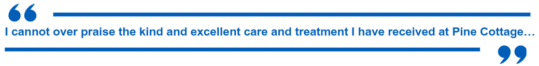

What are the arrangements for visitors?

Visitors

Family, children, and friends are welcome to visit. We ask that you, your family, and visitors consider the privacy of other patients and:

- Show courtesy and respect to patients, family members and all staff.
- Work with staff to get the most from this period of rehabilitation.
- Communicate appropriately with the relevant member of the team. Don’t hesitate to ask questions.
- Always keep pets and children under control.
- Park in appropriate bays and do not block ramps or driveways.

Visiting times

Visiting is held daily between 2pm-5pm and 6pm-8pm.

If it is difficult for your visitors to attend during these times, please discuss this with your nurse and they will do their best to help arrange a suitable option, while ensuring this is not disruptive to your therapy sessions. At times during visiting hours staff may need to suggest rest periods dependent upon your needs; this is an important part of your recovery. The aim is to get a balance of rest and therapy to enable you to achieve the best outcome.

Pets

Pets may be brought in at the discretion of the nurse in charge. We have an information leaflet on bringing pets into the unit and your visitors are expected to clean up any mess their pet might make.

What are the arrangements for mealtimes?

Protected mealtimes

Mealtimes are an important part of your rehabilitation and recovery. We run a protected mealtime system, which we ask visitors not to disturb. This ensures we can provide the ideal environment for you to eat your meals with minimal distractions.

- Breakfast: 7.30am
- Lunch: 12.15 - 1.15pm
- Supper: 5.15 - 6.15pm

A choice of meals and hot drinks are provided throughout the day.
Please discuss any special dietary needs that you may have with the nursing staff or housekeeper. Our aim is to ensure all dietary needs are catered for. Nutritional advice is also available from the nursing team. Arrangements can be made for you to talk to the dietician, if appropriate.

Advice around foodstuffs

The unit cannot take responsibility for the safe handling of food we have not provided and, due to food hygiene standards, we advise against family / friends bringing food in for you.

If, however, you feel this is the only option to ensure your nutritional needs are met then please see our information leaflet about foods that may be at ‘high risk’ of contamination.

Essential foods that are not ‘high risk’ can be stored in the ward fridge for a short time providing it is in an appropriate container, with a name and date on.

Please discuss this with the nursing team who can provide labels if required. Items left in the fridge unlabelled or with a shelf life of less than 24 hours will be removed and disposed of.

What facilities are available at Pine Cottage?

Laundry

Laundry facilities are limited so we ask that you arrange for your family/carer to do your laundry. If you are unable to launder your own clothes, please discuss this with the nursing/housekeeper team.

Chaplaincy

The hospital chaplain will visit you at your request regardless of your faith.

Alternatively, arrangements can be made for you to be seen by someone from your own faith.

The chaplaincy maintains a register of contacts with representatives from a wide variety of faiths.
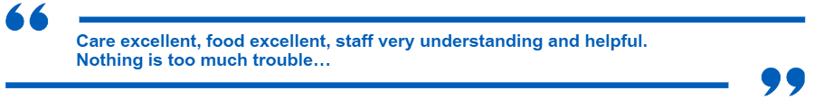

What should I bring with me?

Please bring:

- Comfortable clothes and sensible trainers/shoes which are suitable when attending therapy sessions, and night wear. Storage is limited within your room so only bring enough for a few days at a time.
- Personal toiletries.
- An outdoor coat is needed to attend therapy or to go out on visits as part of your rehabilitation.
- You may also find it helpful to bring a pen, paper, and diary with you.

Personal property and valuables

We regret that the unit cannot accept liability for money or valuables, and you are therefore advised to leave these at home for safe keeping. The only money you are likely to require will be for the Trolley Shop, etc.

If leaving your valuables at home is not an option, the nurse in charge can place them in the hospital safe and give you a receipt.

On discharge you will need to ask the nurse in charge to arrange for the items to be returned. If cash was handed in it is likely to be returned to you as a cheque for the same amount as large amounts of money are not kept on site for security reasons.

Electricals

For safety reasons all personal electrical items must be checked by the site electrician before they are allowed to be used in the unit – please ask staff for advice on this.

Mobile phones

You are more than welcome to keep your mobile phone with you during your stay in the unit. To minimise disruption to other patients we ask you:

- Not to take your mobile phone into your therapy sessions.
- Respect other ward users when using your phone.
- Not to use a mobile phone after 10pm.

Televisions

Each bed has a television with headphones provided.
- Please respect other ward users when using the televisions.
- Televisions to be switched off by 10pm.

What can I expect while I’m at Pine Cottage?

What happens after I arrive at the unit?

You will be shown around the unit and meet the team to discuss your needs and what you would like to achieve during your stay. From this, the team can set aims and plan your care.

During your stay you will be encouraged to do as much as you can for yourself. At first you may need help with washing, dressing, or going to the toilet, but as you become more confident you will be able to do these on your own.

Where possible, staff will provide you with equipment and/or support to help with your recovery and make your discharge easier.

What will I do during the day?

As soon as you arrive at the unit, we will begin work to help you recover.

You will be assessed for a wheelchair and as soon as you are confident in using it you will be encouraged to be as independent as you can.

As therapy sessions will be based on your personal needs you will have goals set with you to achieve.

During the therapy you will be with other people who have also lost a limb. This can be helpful because the group will be at different stages of recovery, and you can learn from others and talk through any concerns you may have.

Your therapy programme is an essential part of your recovery and should take priority over everything else. You will need to attend a therapy session even if you have visitors. In some cases, your family or carer may be asked to join you.

This will outline your future options and help you think about and discuss whether you have an artificial limb.

Medicines

Medicines are prescribed by a doctor and are administered by the nursing staff.

All medicines must be locked away for safety reasons so please ensure all are given to a qualified nurse – even if these are over-the-counter remedies – as these may influence prescribed medicines.

As part of your rehabilitation, we support patients to take their own medicines.
Staff will carry out an assessment to enable you to manage this safely.

We work closely with our pharmacy team to provide your medication in a way which is safe for you during your stay, and for when you are discharged.

Who will provide my care?

Your care will be provided by a team of health and social care professionals who have the experience, skills, and knowledge to offer you a complete rehabilitation service. You may need support from some of these professionals, or all of them.

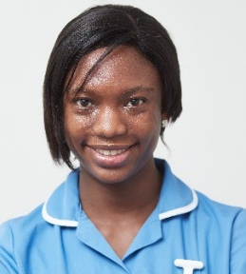
The team includes:

- Consultants
- Lead medical team
- Nursing team
- Physiotherapists
- Occupational therapists
- Therapy and nursing assistants
- Social workers
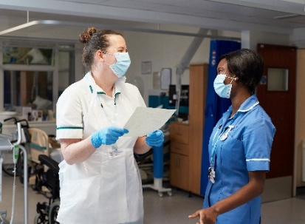
Doctor

Early in your stay you will be seen by a doctor. If your recovery is straightforward, you may only see the doctor once a week. However, if you have any problems or concerns, please discuss these with the nursing team who can, if necessary, arrange for you to see the doctor.
Physiotherapy team

Due to your condition, you will probably have been in bed for some time and your muscles will have become weak. The physiotherapist will show you exercises to strengthen them and stop your joints from getting stiff.

As you become stronger the physiotherapist will teach you exercises that are more difficult and challenging.

Your first physiotherapy appointment
The physiotherapist will check:
- How well you can move around.
- Your muscle strength and range of joint movement.
- Your ability to use a wheelchair; for example, can you move from the wheelchair into a chair or bed.

At first, even with support, you may find it difficult to stand and balance. This will get better the more you move around.

Important note: Exercises reduce swelling and help you to heal. You need to exercise regularly while in hospital and carry on doing this when you go home.

Social worker

If you need home care services when you are discharged, you will be referred to a social worker. They will talk to you about the services that are available.
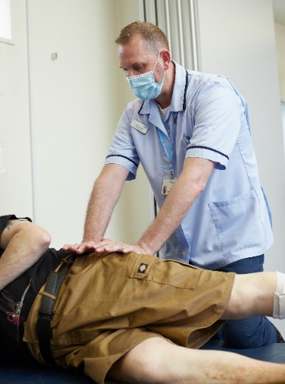
The social worker can also advise you about residential or nursing home care, if needed, and discuss financial issues.

Rehabilitation nurses

Rehabilitation nurses are pivotal members of the team, working as the patient’s advocate. They will also help to coordinate each person’s rehabilitation. This can be a complex but key task to ensuring people get the right care or therapy at the right time. The nursing team ensures that the patient’s care needs are met 24 hours a day, seven days a week.

Occupational Therapy team (OT)

During your first session with the OT, you will be assessed for your own wheelchair. The OT will also want to know how well you are able to manage daily activities, such as getting in and out of your wheelchair; on and off a bed, chair, and toilet; and getting dressed. If you find any of these activities difficult the OT will work with the rehabilitation team to help you to practice.

To make sure you can return home the OT will arrange a home visit during your stay in the unit, if required.

If you need any equipment to help you manage at home, the OT will advise you on where you can get this from.

Further support

Further assistance is offered to patients by our support, housekeeping and administration staff based within the unit.

Why do I need to have an amputation?

Some patients need an amputation because the blood supply to tissue, such as muscle, is not very good.

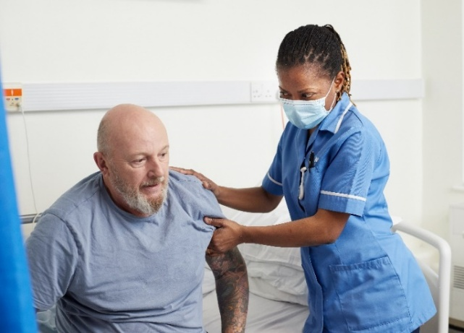
Blood is supplied to all parts of the body by the arteries, which are like tubes. Particularly in smokers and diabetics the arteries can gradually become furred up. Doctors call this Peripheral Vascular Disease (PVD).

PVD happens slowly over several years and may have started with an aching pain in your calf when walking.
Some patients may have had an operation to unblock the arteries or to bypass the blockages.

Sometimes, the onset of PVD is quick and there may be a sudden blockage of a major artery. Someone who is diabetic may have a septic toe or an ulcer that might not heal because there is not enough blood supply to that part of the body.

The lack of, or reduction in, blood to part of the body is called ‘ischemia.’ When the blood supply is at a critical level, the tissues become painful and die. If the dead tissue becomes infected, it results in wet gangrene.

Amputation is necessary to remove the infection and pain from the dying tissue before it spreads. Where possible, the amputation will be a little way below the knee, although sometimes it will be higher up because the blood supply is not good enough.

If your amputation has been done for a different reason and you need information on this, ask a member of the team to discuss this with you.

Having an amputation will help you to manage on your own and gain control.

How will I feel after my operation?

After your operation you may feel some discomfort or pain for a while, but this will be controlled by medication.

If your painkillers are not effective, please talk to a member of staff, who will be able to help. You will not become addicted to painkillers if you are only taking them for a short time and you will not make progress if you are in pain.

As part of your rehabilitation, nursing and pharmacy staff will talk to you about how to manage your own medication while you are in the unit. This will also help when you are discharged.

At some point after your operation, it is likely that you will feel sad and depressed about the loss of your limb. You will no longer feel complete, and whenever you need to move around you will be aware that you have lost an important part of your body.

These feelings affect people in different ways. Some feel cheated as though they have suddenly lost an old friend. Some people are not able to talk about it or ignore the fact that they do not have a leg. Others have strong, clear memories about what their leg looked like and even dream about it. All these feelings are normal, so you do not need to be alarmed or distressed.

At times you may feel as if your limb is still there; this is called a ‘phantom limb.’ It may feel like you have ‘pins and needles’ and the feeling may even make you want to try and stand on a foot which is no longer there. If this feeling becomes too distressing or painful you may find it useful to discuss this with your nurse. Again, these feelings are normal.

How will I get to the toilet?

At the beginning of your recovery, it is likely that you will need some help getting on and off the toilet. A member of staff will help and show you the safest way to do this. As you become stronger you will be able to manage this by yourself.

For a short time after your amputation, you may have a tube in your bladder so you can pass urine. This is called a urinary catheter. One of the nurses will talk to you about this.

Can I have a shower?

Yes. Nearly all patients who have had an amputation may have a shower, so it is up to you to tell the staff looking after you when you would like one.
A nurse will help you get in and out and may need to use equipment to help with this. As you become stronger you may be able to do this by yourself.

When will my clips or stitches be taken out?

Usually this will happen 14 - 21 days after your operation, but nursing staff will talk to you about this and will advise you about the best time for them to be removed.

A wound can sometimes become infected. If this happens, the wound will take longer to heal and may change when the stitches are removed. The nursing staff will talk to you if a change in treatment is needed.

Will I have an artificial limb?

The aim of your rehabilitation programme is to help you manage on your own as much as possible, so an artificial limb will only be considered if it will help you to achieve this. It is not appropriate for everybody to have an artificial limb and some patients may decide not to have one.

If you want to walk again, you must be aware that it will take a lot of hard work and a great deal of effort and commitment from you. Learning to use an artificial limb can be a long and tiring process, so you will need to be physically and mentally able to manage this.

Whether you have a limb or not is decided by you and the team looking after you. Once a week, the team meets to talk about how you are doing. If you and the team agree that having an artificial limb will help you; an arrangement will be made for you to see the prosthetic fitter to talk this through. Prosthetic fitters are specialists in making and fitting artificial limbs.
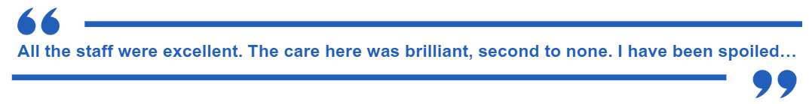

What happens if I am going to have an artificial limb?

When your stump has healed enough, you will be given an appointment at the Limb Centre, which is part of the Re-enablement Services Centre (RSC). The RSC is part of Norwich Community Hospital.

At your first appointment you may be measured so that a socket can be made. If your leg has not healed enough, you will be given another appointment.

Soon after you have been measured you will have a further appointment at the Limb Centre to fit your artificial leg. The physiotherapist will teach you how to put your artificial leg on and take it off and show you the best way to walk with it. They will advise you about how long to wear it and provide you with a walking aid to help support you.

Your ability to walk, and the length of time you can wear your limb, will improve with practise.

What happens if I am not going to have an artificial limb?

If it’s not possible for you to be fitted with an artificial limb, it is still important for you to continue with your rehabilitation. This will help you to manage on your own, in your wheelchair, and with daily activities.

It is important for you to understand that if you do not have an artificial limb, you have not failed in any way. This decision is based on what is right and best for you which you will be included in. You will be reviewed 6/8 weeks after discharge.

What are the arrangements for my discharge and follow-up treatment?

Plans for your discharge and for potential follow-up treatment, will be made early in your stay. They will be discussed with you and your family before any final decisions are made.

Your length of stay in hospital will depend on how well you have progressed, if any alterations need to be made to your home, or homecare services arranged.

Further Rehabilitation

Homecare services

The aim of homecare services is to help you manage on your own at home. You might need the services for a short time until you are fully recovered, or long term so that you are able to remain in your own home.

If you agree that you need homecare
services, we can make a referral to a social worker. They will talk to you about what services are available and, if necessary, make arrangements before you are discharged.

Medication

When you are discharged you will be given a minimum of two weeks’ supply of your medication. After this, you will need to get a prescription from your own GP.

Community services

Your GP will be told that you have been discharged and given details about what has happened while you have been in hospital.

Arrangements may be made for a community nurse to visit you at home, or you may be asked to see your practice nurse at your GP surgery or health centre.

Further rehabilitation

If it is necessary for you to continue your rehabilitation programme as an outpatient, this may be provided in an outpatient clinic on this site, at specialised clinics elsewhere, or within your own home.

Arrangements may also be made for you to be seen in the amputee clinic at the Re-enablement Services Centre (RSC) or the hospital clinic if you haven’t been given a limb. If you are attending the RSC, they will provide you with all the information you need so that you can contact them if you need to.

Your experience of our care

As part of our aim to continually improve the quality of our services we need to know what you think about the care we have provided. We want to hear any comments you may have so that we can keep getting better together.

If you do have concerns about any aspect of your own, or your relatives care during your time at the unit we would urge you to speak to a member of staff as soon as possible to help us put things right straight away.

We also love to receive your positive feedback and compliments as these let us know we are doing our job correctly – letters and cards can be handed in at the unit.

Comments, Compliments and Complaints

A leaflet on how to formally lodge your Comments, Compliments and Complaints is available from a member of staff, or you can log onto our website:
www.norfolkcommunityhealthandcare.nhs.uk

Patient Advice and Liaison Service (PALS

NCH&C PALS offers support and advice for patients and carers and can help to answer your queries / comments on:
Freephone (landlines only): 0800 088 4449
Email: pals@nchc.nhs.uk

Patient Experience Surveys

You can also help us to improve our services by completing any patient satisfaction surveys offered to you during or after your stay.

Charitable donations

If you would like to make a charitable donation to the centre, please ask a member of staff for the ‘Supporting your local community health service’ leaflet which will give you all the information you need to make your donation.
Further information or advice

Age UK Norfolk

An independent charity working with older people living in Norfolk.
Tel: 01603 787111
Web: www.ageuk.org.uk

Benefit Enquiry Line

Provides benefit advice and information for disabled people and carers on the range of benefits available.
Helpline: 0800 882 200
Textphone: 0800 243 355 (for people with speech or hearing difficulties)

British Red Cross

Offer a range of services for older people and those with a disability.
Tel: 01603 426361
Web: www.redcross.org.uk

Disability Rights Norfolk

A comprehensive advice service that covers all Department for Work and Pensions benefits relating to illness and disability.
Tel: 01508 491570
Web: www.ncodp.org.uk

East Anglian DriveAbility

Assessment and advice for people with disabilities, who wish to drive, return to driving, be a passenger or use an outdoor powered vehicle.
Tel: 01842 753029
Web: www.eastangliandrivability.co.uk

Limbless Association

Provides information and support to individuals, about to have an amputation or already living with limb-loss.
Helpline: 0800 644 0185
Web: www.limbless-association.org
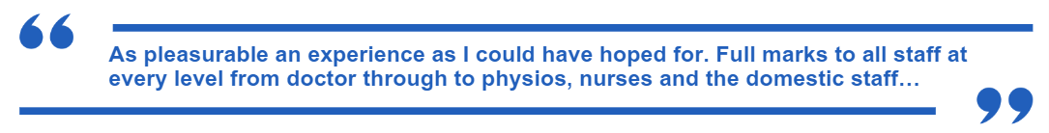

Norfolk Disability Information Service

Signposting service for people with disabilities and their carers.
Tel: 01603 729802
Web: www.norfolk.gov.uk

Re-enablement Services Centre

Provides services for people with disabilities.
Tel: 01603 216956/7
Web: www.norfolkcommunityhealthandcare.nhs.uk

THP Mobility

• Short and long-term scooter hire
• Sales, repairs, and servicing
• Advice on stair lifts and equipment
Tel: 01603 784777
Web: www.thpmobility.org.uk

Steel Bones

Telephone: 01223 734000
Address: Stirling House, 3 Abbeyfields,
Bury St Edmunds, Suffolk IP33 1AQ
Email: hello@steelbone.co.uk

Limb Power

Address: Limb Power, Whitecroft,
Tandridge Lane, Lingfield, Surrey, RH7 6LL
General Enquiries: 07502 276858
Email: info@limbpower.com

Contact Information

The Colman Centre for Specialist Amputee Rehabilitation Service
Pine Cottage, Colman Hospital, Unthank Road, Norwich, NR2 2PJ

Tel: 01603 251260

Smokefree Policy
Norfolk Community Health and Care NHS Trust operates a smoke free policy at all its sites. Smoking is not allowed by anyone entering our buildings or grounds.

If you do smoke, you can receive support with giving up from our Smokefree Norfolk service. A leaflet on the service can be found at all our sites or just ask any member of staff.

Accessible formats

If you would like this publication in large print, Braille, an alternative format, or in a different language, please contact us on 0800 088 4449 and we will do our best to help.

Feedback
If you have any queries about our services, or would like to provide feedback, please contact our Patient Advice and Liaison Service:

- Telephone: 0800 088 4449
- Email: eec.pals@nhs.net
- Opening hours: Monday to Friday, 9am–5pm
Friends and Family Test
You can also tell us how likely you are to recommend our service to friends and family if they needed similar care or treatment. Your feedback helps our staff understand what they are doing well and where improvements can be made.

Ask a member of staff for a Friends and Family Test form, or visit:
www.eastofenglandcommunityhealthandcare.nhs.uk/patient-experience/patient-advice-and-liaison-service-pals/
Produced by: East of England Community Health & Care NHS Trust
Date of publication: Month Year
Leaflet review date: Month Year Version: Version Number

